Early Career People in Water Conference 2022

Advert

Are you working or doing research in Water and would like a more equitable, diverse, and inclusive water sector?

The Early Career People in Water Conference aims to provide a platform for early career researchers and young professionals to share and discuss the latest advances and innovation in Water and ways forward for a more equal, diverse, and inclusive water sector.

The conference will take place at Cranfield University on 16th and 17th November 2022. It will include site visits, networking, keynote speeches, technical presentations from early career people and a panel discussion on how to promote diversity and inclusion within the water sector.

Registration is now open! You can contribute with a presentation or a poster by submitting an abstract before 26th September 2022. For more details, check the conference website.

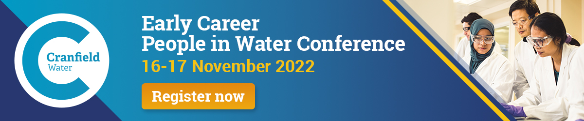

Social media posts

- https://twitter.com/cranfieldwater/status/1554132372601425921
- https://twitter.com/cranfieldwater/status/1561747295095476224
- https://twitter.com/iwaywp/status/1562060340078284801
- https://www.linkedin.com/posts/amomblanch_early-career-people-in-water-conference-activity-6960551692727676928-N9vU?utm_source=share&utm_medium=member_desktop

